Credential access ntds.dit case report

Since case is related to ntds.dit start with keyword ntds.dit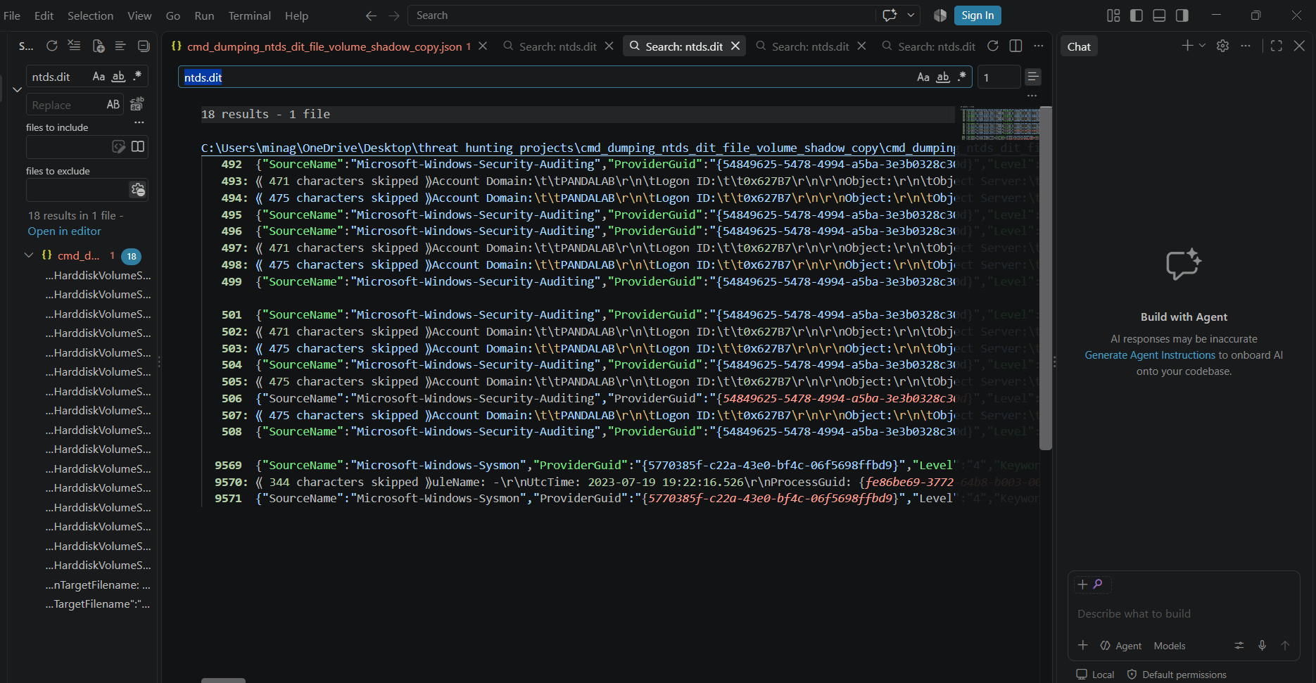
And observed following permission for ntds.dit object
Accesses: READ_CONTROL
SYNCHRONIZE
ReadData (or ListDirectory
ReadEA
ReadAttributes
Access Reasons:
READ_CONTROL: Granted by Ownership
SYNCHRONIZE: Granted by D:(A;ID;FA;;;BA)
ReadData (or ListDirectory): Granted by D:(A;ID;FA;;;BA)
ReadEA: Granted by D:(A;ID;FA;;;BA)
ReadAttributes: Granted by D:(A;ID;FA;;;BA)
Access Mask:0x120089
Privileges Used for Access Check:-Restricted SID Count:0",
Part | Meaning
D: | DACL — Discretionary Access Control List
A | Allow — the permission is allowed
ID | Inherited — the permission was inherited from a parent folder/object
FA | Full Access
BA | Built-in Administrators group
This means the for readdata, readea, readcontrol, synchronize, readaatributes acl allows full access to bulit in administrator group.
The duplicate ntds.dit is craeted
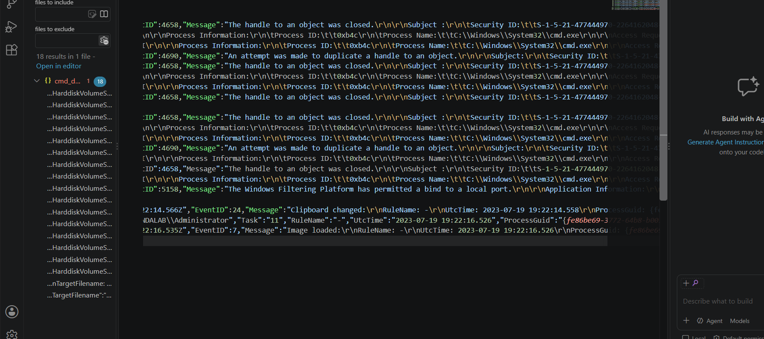
The cmd.exe sha was of 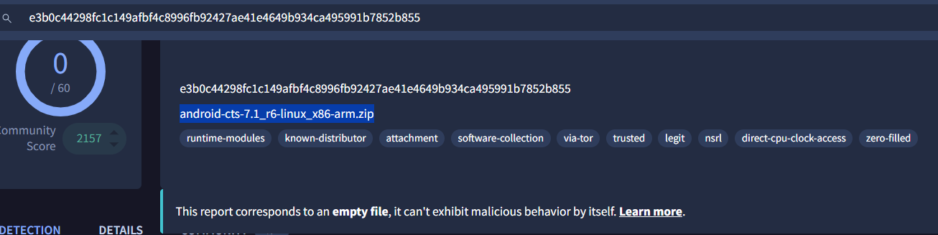 which is used by google for testing accessing the ntds.dit file
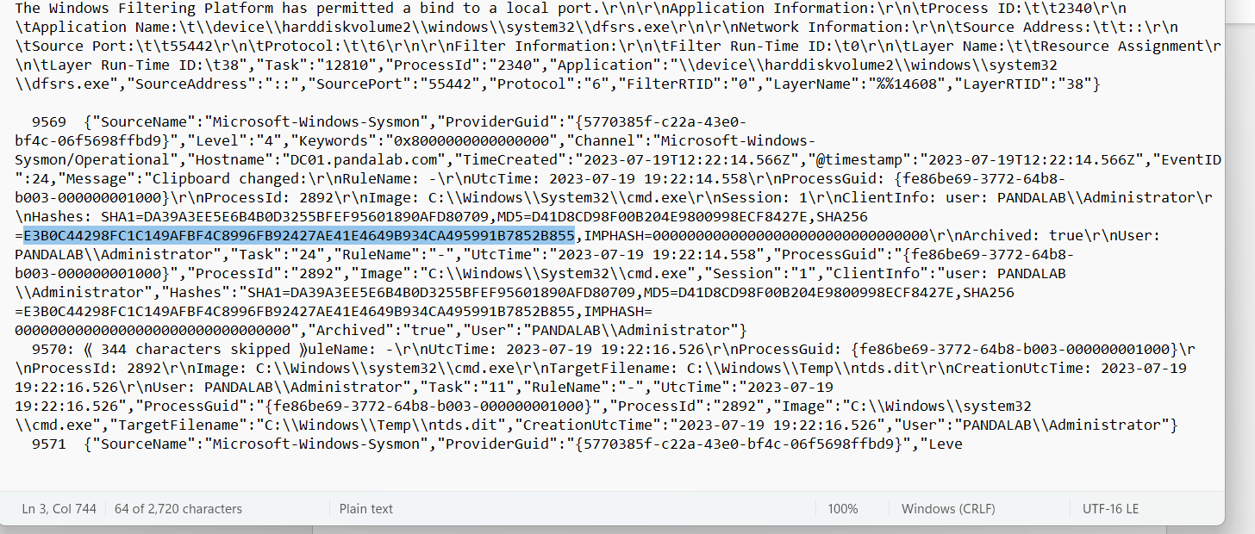
That file android-cts-7.1_r6-linux_x86-arm.zip is executed as cmd.exe.
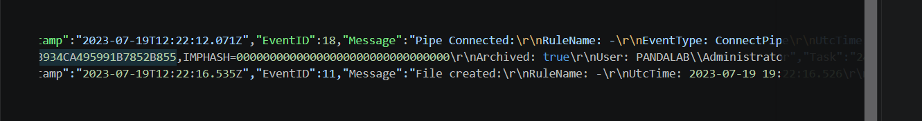
Overall activity
The google android test file is used to access the ntds.dit file in active directory services in domain controller , creates duplicate and admin has full access to the ntds.dit . So it is a testing activity.

